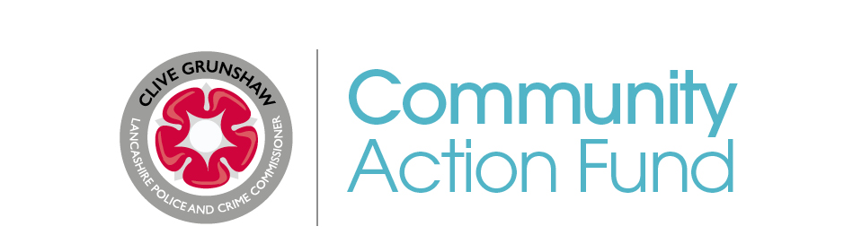

APPLICATION FORM

Lancashire Police and Crime Commissioner
Commissioner's Community Action Fund

APPLICATION FORM

The data submitted by you on this application is will be handled in accordance with current data protection law and our Privacy Notice

Projects / Initiatives must adhere to the government's current COVID-19 guidelines.
Further information regarding COVID-19 can be found here

Section A: Your Organisation
Name of Organisation:
Name of Project:
How many trustees / members of the management committee do you have?

How many paid staff (excluding trustees)?

How many volunteers (excluding trustees)?
Is your organisation part of Our Lancashire? Yes: No:
If no, would you be happy for us to pass your
details onto Our Lancashire? Yes: No:
(Please note this will not affect your Community Action Fund application)
Name and Address of Project Organiser:  Daytime Telephone No:  Home No:  Work No:  Email:  Position in organisation: | Name and Address of Contact (if different from Project Organiser):  Daytime Telephone No:  Home No:  Work No:  Email:  Position in organisation:
Name of the organisation who will deliver the Project:
(If different from above)
Is your organisation and formally constituted group? Yes: No:
If 'Yes' please provide a copy of your constitution along with a copy of your latest accounts.
If 'No' please contact LANPAC who may be able to assist with funding via their own scheme.
Please tick to confirm whether you have the following documentation:
Public Liability Insurance - If 'Yes' amount of cover £
Employers Liability Insurance - If 'Yes' amount of cover £
Indemnity Insurance - If 'Yes' amount of cover £
Adult Safeguarding Policy
Child Safeguarding Policy
Equality & Diversity Policy
Business / Strategic Plan
Section B: About your Project
Proposed start date: | Proposed end date:
Where will the project be located?
Give an outline of your project including details of the problem, issue or topic being tackled and who will benefit: (Max 500 words)
Total cost of the project?
Please provide a full breakdown of cost?
How much are you requesting from the Commissioner's Community Action Fund?
How will you measure your project has been successful?

If your project provides services and/or support to individuals please indicate how many people you plan to engage with the project?
Please provide details of any other resources or match funding you are using to support this project?
Which of the Police and Crime Commissioners Priorities does your support?
Protect local policing

Tackling crime and reoffending

Supporting vulnerable people and victims

Developing safe and confident communities
Are there any other partners involved in your project?
(e.g. Community Safety Partnerships, Local Reducing Reoffending Boards etc.)
Section C: Details about the Fund
How did you hear about the Police and Crime Commissioner's Community Action Fund?

Police and Crime Commissioner's Website (www.lancashire-pcc.gov.uk)
Our Lancashire
Local Council / CSP
Your Local County Councillor
Local Neighbourhood Policing Team
Newspaper
Word of mouth
Social Media (Facebook and/or Twitter)
Other (please specify)
The Commissioner's Community Action Fund is administered by LANPAC on behalf of the Police And Crime Commissioner.

Please email all completed forms and supporting documents to lanpac@lancashire.pnn.police.uk

Alternatively, printed forms and supporting documents may be posted to:
LANPAC, Lancashire Constabulary Headquarters, Po Box 77, Hutton, Preston PR4 5SB.

For further details about the Commissioners Fund please contact:
Al Yusuf: 01772 412796
Please sign to confirm the information you have provided is true and accurate:

(Please note electronic signatures may be used)

By signing this form you agree to the information about your organisation and this project being shared with other relevant agencies and partnerships.
(E.g. Community Safety Partnerships, Lancashire Constabulary, Local Reducing Reoffending Boards etc.)

MONITORING INFORMATION

Your answers to this section will not affect your grant application and are for monitoring purposes only.

Please indicate whether your project is specifically targeted at people within one or more of the protected characteristics listed below.
(Tick appropriate)

- Male Female Transgender Not Targeted

- Young people (under 25) People 25-65 Older People (65+)
Not Targeted

- People with disabilities (physical, emotional or mental)
Not Targeted

- Gay Lesbian Bisexual Heterosexual Not Targeted

- Race (including ethnic or national origins, colour or nationality)
Please specify: __________________________________
Not Targeted

- Specific religion or belief
Please specify: __________________________________
Not Targeted

Is your organisation set up to specifically advance the interest of any of the groups above and if so which ones (gender / age / disability / sexual orientation / race / religion)?
______________________________________________________________

TERMS & CONDITIONS

- The maximum grant that can be applied for is £3,000.
- If your organisation is already receiving funding from one of the Commissioner's other grant or commissioning streams you are not eligible to apply for Community Action Fund funding.

- The Grant must be used for the project or scheme detailed on the Application Form and may not be used for any other projects or schemes.

- If the full Grant is not used for the proposed project or scheme any underspend must be returned to the Commissioner's Community Action Fund.

- If your application is successful you will be expected to provide bank account details for your organisation. Funding will normally be paid into the nominated Bank Account by BACS payment. In certain circumstances LANPAC may propose making payment direct to a service / equipment provider where this would be of benefit to the local group.

- An Evaluation form will be completed by the Applicant at the end of the project. If your project engages with individuals a minimum of two anonymised cases studies will be required.

- The "Commissioner's Community Action Fund" logo should be used on all literature associated with the project or scheme and this should be credited as the funding source in all media and press releases. By accepting the Grant you will be agreeing to the Police and Crime Commissioner being able to use details of your project or scheme in publicity and media releases.

- The Police and Crime Commissioner or a member of his Team will attend project opening or launch events where possible – details of these are to be provided to LANPAC.

- These Terms & Conditions should be read in association with the Grant Guidance notes which are available on the Police and Crime Commissioner's and LANPAC websites or in printed form from the LANPAC office.

